**BIOMÉRIEUX VITEK FLEXPREP SOP**

**Purpose**: The introduction of the VITEK MS Prime in the clinical microbiology lab at HUP came in parallel with the implementation of a new software that allows for easier preparation of identification and antimicrobial susceptibility testing. This software brings operator and reagent traceability and can be accessed from any **networked** computer (you can do this remote if connected to the VPN). **Note**: you must have permission from the microbiology directors in order to utilize the instruments. Please also inform Laura if you will be using her log-in information.

**Slide Set up**

1. In the web address bar, type “**170.166.93.19**.” This IP address will take you to the Biomérieux portal page.
2. To set up a MALDI slide, click the “**VITEK** **FLEXPREP**” icon.
3. Sign in:
   1. **Username**: Cowdenl
   2. **Password**: Biology123
4. The “Layout” button on the right hand side of the page (you may have to scroll right, depending on the size of your screen) will allow you to change between VITEK AST and Vitek MS set ups. Click the “**Layout**” button until you see this screen:

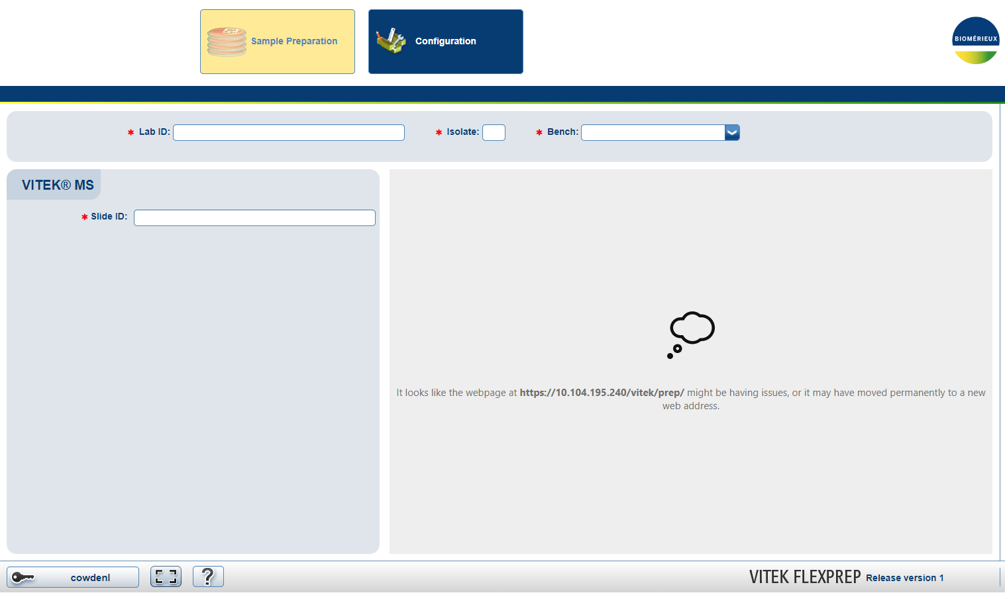

**Figure 1**. VITEK MS Set Up

1. In the “Slide ID” field, enter or scan your slide barcode number. **Note**: It should contain a **capital** DS in the beginning.
2. Preparation mode should read “**IVD**.”
3. In the “Bench” field, select “**AMT**” from the dropdown.
4. Click “OK.”
5. Type in your matrix lot number and expiration date. **Note**: the program will inform you whether or not your reagent is expired, but it will continue on regardless.
6. Click “OK.”
7. The next screen should populate as shown in figure 2, containing an image of the slide.
8. In the “**Setup** **Operator**” drop down, select “**Cowden**.”
9. Click the spot on the slide where you want to begin your entries, otherwise, it will begin entering them on position A1. In the “Lab ID” field, type or scan your first sample and hit enter. **Validate that entry by hitting the F12 button**. The selected spot will now have turned dark blue, meaning that a sample has been entered on that spot.
10. You can click the position on the slide where you want to add your next isolate, otherwise it will automatically go to the next position. Continue the process from step 13 until you’ve entered all of your isolates you wish to ID.

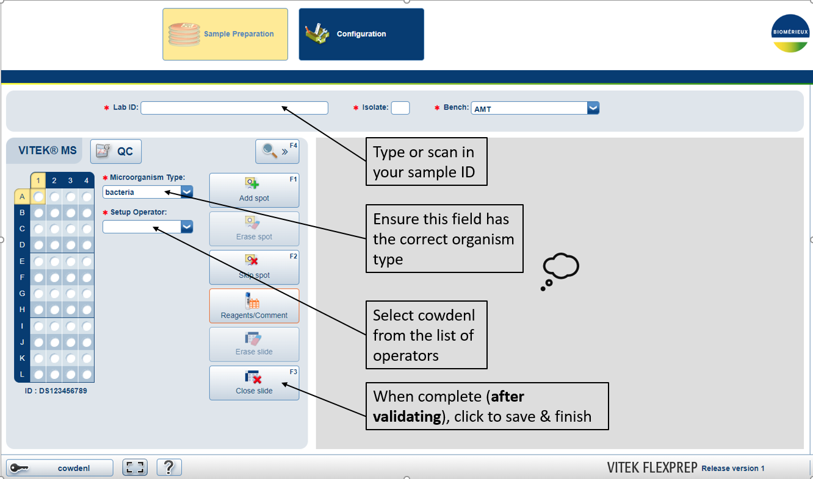

**Figure** **2**. Slide Set Up

1. Once complete, hit the “**Close Slide**” button, which will send your slide to the server.
2. If using the **Legacy instrument**, you can accession your slide as previously done.
3. If using the **VITEK MS** **Prime**, you can simply insert your slide into the instrument. You do not need to log-in to the instrument.

**Reviewing Results**

1. In the web address bar, type “1**70.166.93.19.**” This IP address will take you to the Biomérieux portal page.
2. To view results, click the “VITEK MS SOFTWARE” button.
3. Sign in:
   1. **Username**: Cowdenl
   2. **Password**: Biology123
4. Click “Results to Review” and a list of results will populate on the screen. All of those listed may not belong to you or your slide, so discriminate yours by the Accession ID you created during setup. **Note**: you can filter results according to operator by clicking the “Search Criteria” button in the upper right hand corner and selecting “Cowden” under Setup Operator.
5. When you’ve successfully taken note of your results, please remove them from the “Results to Review” section by selecting them and clicking “Reject.”

**Helpful Tips**

* Some species may be identified with a “N” by their name. This means that that particular species is not validated on the instrument according to the 510K FDA approval of the instrument and software. Some of these may have been internally validated by the microbiology lab; you can feel free to ask Microbiology to check for you.
* Members of the *Enterobacter cloacae complex* often do not ID down to species level to what the instrument deems an acceptable certainty. Use “*Enterobacter cloacae complex*” where appropriate.